GYERE® Children’s health program  HUNGARY, 2019 | CONTACT  Hungarian Dietetic Association mdosz@mdosz.hu President: Jolan Kubanyi

GYERE® - Gyermekek Egészsége („Children’s Health”) Program

Background:
Childhood obesity is reaching alarming proportions in many countries and poses an urgent and serious challenge. The Sustainable Development Goals, set by the United Nations in 2015, identify prevention and control of noncommunicable diseases as core priorities. Among the noncommunicable disease risk factors, obesity is particularly concerning and has the potential to negate many of the health benefits that have contributed to increased life expectancy.
The prevalence of infant, childhood and adolescent obesity is rising around the world. Although rates may be plateauing in some settings, in absolute numbers there are more children who are overweight and obese in
low- and middle-income countries than in high-income countries. Obesity can affect a child’s immediate health, educational attainment and quality of life. Children with obesity are very likely to remain obese as adults and are at risk of chronic illness.
Many children today are growing up in an obesogenic environment that encourages weight gain and obesity.
Energy imbalance has resulted from the changes in food type, availability, affordability and marketing, as well as a decline in physical activity, with more time being spent on screenbased and sedentary leisure activities. The behavioural and biological responses of a child to the obesogenic environment can be shaped by processes even before birth, placing an even greater number of children on the pathway to becoming obese when faced with an
unhealthy diet and low physical activity. No single intervention can halt the rise of the growing obesity epidemic. Addressing childhood and adolescent obesity requires consideration of the environmental context and of three critical
time periods in the life-course: preconception and pregnancy; infancy and early childhood; and older childhood and adolescence. In addition, it is important to treat children who are already obese, for their own well-being and that of
their children. Obesity prevention and treatment requires a whole-of-government approach in which policies across
all sectors systematically take health into account, avoid harmful health impacts, and thus improve population health and health equity.

The Commission has developed a comprehensive, integrated package of recommendations to address childhood obesity, including implementation of comprehensive programs that promote healthier food and beverages choices, implementation of comprehensive programs that promote physical activity and to provide family based multi-component services to prevent obesity.

Obesity is one of the most emerging health conditions in Hungary affecting a significant proportion of the local population. According to the latest national health survey in 2014, 62% of adult women and 67% of men, in total about 5 million people had excess weight. The proportion of overweight and obesity increases with age: more than a third of young women, two in three of middle-aged women, and more than three-quarters of the elderly have excess weight. Two-fifths of young men, three-quarters of middle-aged people and more than four-fifths of the elderly are overweight or obese. Proportion of weight excess has doubled between the 1980’s and 2014 (Figure 1) - one out of three adults is obese and one is overweight.
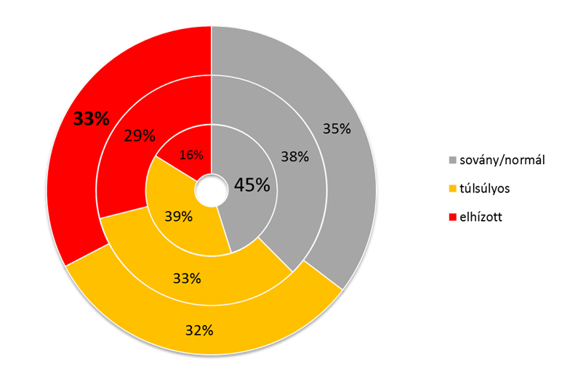
Figure 1: Trend of obesity and overweight in Hungary (1988; 2009; 2014) – grey=undernourished, yellow=overweight, red=obes

Looking at obesity from an international perspective, Hungary is the fourth on the obesity ranking amond the OECD countries (Figure 2).
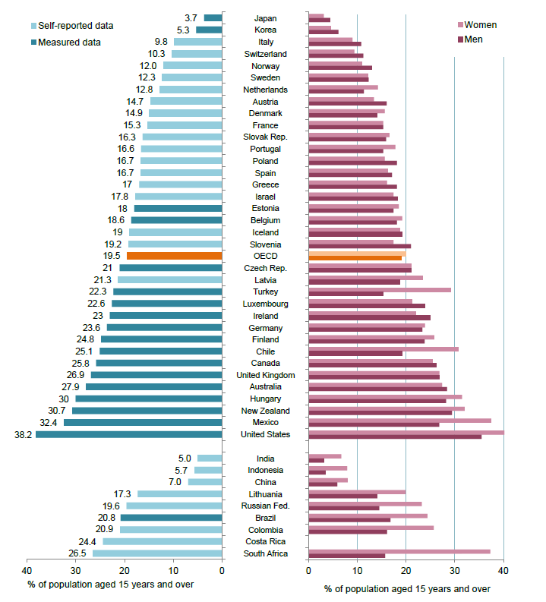
Figure 2 -- Obesity among adults, 2015 or nearest year (OECD)
The share of children who are overweight or obese at age 15 has steadily increased since 2000 in Hungary, according to the Health Behaviour in School-aged Children survey (Inchley et al., 2016). Nearly two in ten 15 years children reported to be overweight or obese in 2014. (Figure 3)

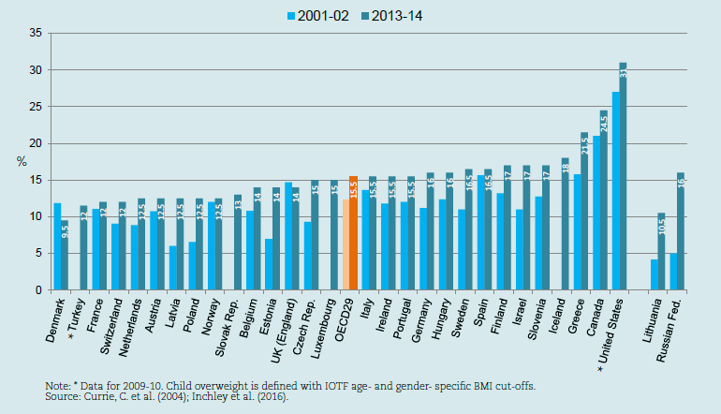
Figure 3 -- self-reported overweight (incl. obesity) in children aged 15 years (OECD)

Project lead and central coordination:
Hungarian Dietetic Association
www.mdosz.hu

The Hungarian Dietetic Association (HDA) was established in 1991 as a NGO. It has almost 1300 members, including qualified dietitians (BSc), post – graduate dietitians (MSc), lots of dietetic students, and legal entities as supportive members. Dietitian is a food and nutrition expert, who completed higher education. A dietician uses nutrition science to manage foodservice operations, educate, and treat healthy and unhealthy individuals and groups.

The aim of the Hungarian Dietetic Association:
- Prevention of diseases, to keep and improve population health and to develop healthy or adequate to current
state of health eating habits through positive influence.
- Our first goal is to improve Hungarian population’s health, with the help of other co-organizations.
- Promoting and enabling the dietitians’ work and experience among the population, knowledge dissemination,
developing and implementing multiple and complex utilization strategies.

The association has given priority to joining the EPODE network, as the international program is supported by the
WHO and the European Commission, and the international network has been able to show a number of positive
results over the last few years.
EPODE is the largest global childhood obesity prevention program, which was first launched in 2004 in France, now
implemented in 29 countries, in lots of towns. It’s most important goal is to help local communities and its members to develop an active and healthy lifestyle, an essential part of which is to teach nutrition and obesity prevention to
children. The Hungarian Dietetic Association taking in consideration the objectives mentioned above has created the
GYERE® program in 2014 by launching a pilot-program in Dunaharaszti. The Hungarian Dietetic Association started the second GYERE® project in Szerencs in 2015 and the third program in Diosgyor in 2018. The three years long program is aiming to prevent obesity as part of the EPODE International Network. Main objective of the GYERE program is to prevent childhood obesity by acting on the behavior of the whole family, changing its environment and community norms.
The GYERE® Program is coordinated by the Hungarian Dietetic Association in close collaboration with political, scientific and private partners.

Political and scientific support, private partners:
Ministry of Human Capacities, State Secretary of Health
Municipality of Dunaharaszti, Szerencs and Diosgyor
Semmelweis University, Faculty of Health Sciences
National Institute of Children’s Health (recently as part of the State Secretary of Health)
National Institute of Pharmacology and Nutrition
Schools and kindergartens of the intervention communities (incl. teachers)
Family-health visitors network
Local media, shops, restaurants, sport facilities, school canteens

Method:
The GYERE® program is structured based on the EPODE four pillars model:
- Political commitment: Gaining formal political commitment at central and local levels from the leaders of the key organization(s), which influence national, federal or state policies as well as local policies, environments and childhood settings;
- Resources: Securing sufficient resources to fund central support services and evaluation, as well as contributions from local organizations to fund local implementation;
- Support services: Planning, coordinating, and providing the social marketing, communication and support services for community practitioners and leaders;
- Evidence: Using evidence from a wide variety of sources to inform the delivery of EPODE and to evaluate process, impact and outcomes of the EPODE programme.

Project Structure:

1. Preparatory

1.1 Setting partnerships
The HDA contacts the Local Government, and requests for hosting the program, than sign a contract with the co-operating partners, including EPODE International Network, State Secretariat of Health, Faculty of Health Sciences at Semmelweis University and National Institute of Child Health. Getting in contact with all educational institutions of the local community to inform them about the program's objectives and operation, outrech to families during Parents’ Meetings, and together with the Local Government other forums and committees of the municipality are also informed.

1.2 Baseline survey
An authorization is requested from the National Scientific and Ethical Committee of the Medical Research Council of
Hungary (TUKEB licence) for carrying out the measurements, so the data collection was approved by the council
mentioned above.

1.3 Recruitment of collaborating experts
Collaborating dietetic experts are recruited based on the geographic location of the intervention community. A preparatory training is held for the experts before starting the program, on which they received detailed information about the program elements ans evaluation.

1.4 Development of communication tools and channels
Online nutrition counseling was developed in the preliminary period, what is free to use by the parents living in
the intervention community, as well as GYERE Facebook page and the GYERE Dunaharaszti website, which can be reached through the association’s website. PR plan is set-up by a PR agency, scientific out-reach plan is designed by the science committee of the Association. Press conference is held to kick-off the project in every locations.

1.5 Program plan and production of the educative materials
Educative content (incl. used handouts, contents for techers and parents, interactive training materials) is developed by the Association’s science committee with involvement of the Semmelweis University, Faculty of Health Sciences, Department of Dietetics. Nearly 300 different handouts are made to be used during the three-year program, about the eight topics, including parents and teachers handouts. (Figure 4) Communication materials are adapted to children’s age.

2. Intervention

The health education program targets primarily the 0-18y children, but information is continuously given also for teachers and parents. Families with 0-3 years small children are also involved via the local family health visitors network and daycares.

2.1. Core education
Experts of the Hungarian Dietetic Association hold various activities as interactive lectures and games targeting children in schools and kindergartens. The program follows an in-depth approach, 3-4 months is dedicated for each topic what allows children to have a deeper knowledge and understanding. The intervention period is consist of eight messages around balanced eating and active, healthy lifestyle: benefits of fruit and vegetables, whole grains, importance of proper hydration, role of meat and fish in the healthy diet, milk and dairy products, sweets and desserts, how to reduce fat and salt consumption, local dietary recommendations (OKOSTÁNYÉR®, ”smart plate”).
Physical activity is also an integrated part of the program, each lessons are closed by a short exercise, additionally one month is dedicated to active lifestyle with involvement of local health celebrities.
The program regularly engages with parents, educative materials on healthy eating and active lifestyle is given. Parents are continuously informed about status of the program on regular parent-teacher meetings.

2.2 Side Activities

To support active and continuous involvement of children and families:
- A special GYERE® menu is served in canteen of all primary and secondary schools.
- Drawing contest and salad-party
- A free-off charge online nutritional conselling by dietician experts is available for all families.
- The GYERE® Santa arrives to kindergartens in every year
- Experts of the GYERE® Program are actively involved in every local community events and activities to provide dietary counselling and interactive games for children and families.
- A huge family event the „GYERE® Day” is organized on the end of the school-year with entertaining activities on healthy lifestyle for the whole community.
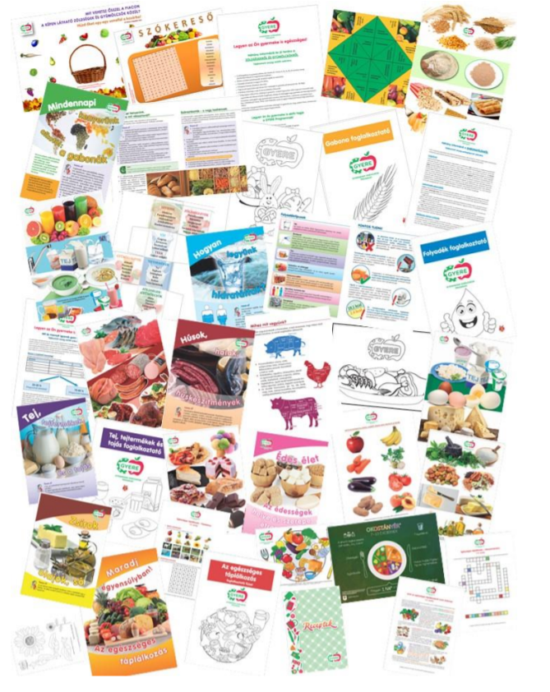
Figure 4 -- educative materials of the GYERE program
3. Evaluation
The measurement of the effectiveness of the program is part of the project objectives by performing and analyzing two points: examination of the nutritional status of participating children at the start and end of the program. The change in the ratio of children with different nutritional status during the program is a significant and objective indicator of the effectiveness of the intervention. The measurements are approved by the National Scientific and Ethical Committee of the Medical Research Council of Hungary.

GYERE projects in Hungary:
Venue | program period | collaborating institutions | number of actions | number of participants | sponsor
Dunaharaszti | 2014-2017 | 1 secondary school,  3 primary schools, 5 kindergartens | 992 | 3500 children+300 0-3y small children | The Coca-Cola Foundation
Szerencs | 2015-2018 (+2 years maintenance in 2019-2020) | 2 secondary schools, 2 primary schools, 3 kindergartens | 720 | 2200 children+200 0-3y small children | the Nestlé Healthy Kids Program
Miskolc-Diósgyőr | 2018-2020 | 3 secondary schools, 5 primary schools, 4 kindergartens | in progress | 3000 children+200 0-3y small children | the Nestlé Healthy Kids Program

Project results:
Project results are available from the two closed GYERE program so far.

- Dunaharaszti

Materials and method:
The EPODE - Organizing the Collection of Height / Weight Data of Children in EPODE Towns document was the
methodological basis for this survey. The comparability of the data of the two measurements was ensured by the
same methodology.
The target group was 6-12 years old children. In Dunaharaszti five kindergartens, three primary schools and one
secondary school was included in the survey, all institution to which the children of the target group were attending.
The total sample was 1677 children. Their parents handed over written consent to measurements, and the
children voluntarily participated in the study. Totally 1321 children were measured and recorded.
The final sample size was 1315, because 6 children’s data had to be deleted due to their age of 13. In the sample, the proportion of boys was 50.3% (661), and girls 49.7% (654)
Measurements were performed by health visitors from the local health service. Preparatory trainings were organized
for them before both measurements. Data recording was made at the start of the program, in December 2014, and at the end, between 6 February and 10 March 2017.
The surveyors recorded the measured data directly on a tablet, on the Excel drive data entry interface created by
an IT specialist. Data recorded on the tablet was synchronized via a web connection to the central database.
Statistical analysis was performed with SPSS (PASW) software version 22.0. Same international reference values were used in both researches to determine nutritional status, which provided a basis for approximate comparison.
Results:

- Body Mass Index (BMI)

The average body mass index for children measured in 2014 is significantly higher than in 2017, which is also true by
gender distribution (Table 1).

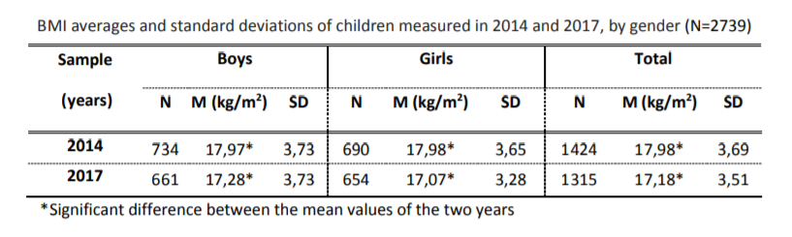

The average values for children between 7 -10 years old are significantly higher in 2014, while there is no statistically
significant difference between the two years averages for other age groups. (Table 2)
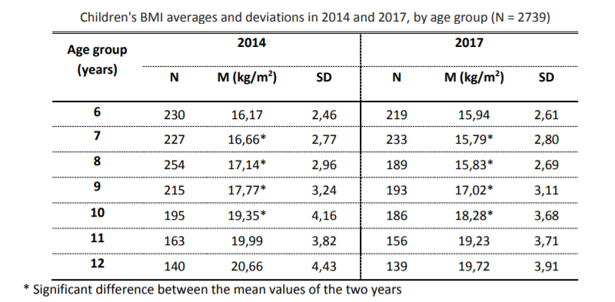

- Nutritional status
There is significant difference in the distribution comparing the full sample of the two years. In 2017 the number of
malnourished children was 9% higher (in percent this means double difference!), while the percentage of overweight
was 5% and the obese was 2% lower than in 2014. The ratio of normal nutritional status was almost the same in the
two samples.
Similarly, significant difference was found by gender distribution between the two years. The only difference was that
in girls overweight and obesity rates were above the average, while in boys were under, between the two years.
Therefore, in the case of the girls the decrease of those with excess weight was even more noticeable, between the
two years of research. In the case of the boys the proportion of normal nutritional status also slightly decreased.
Comparing age groups significant differences were found at ages 7-9 years old. Their characteristics were similar to
the whole sample. However, difference between the data of the two study years was more obvious at the ages of 7-
8 than the average.
In 2017 the increase of malnourishment was 15% in the 7-year-olds, and 20% in 8-year-olds. At the same time, the
number of children with normal nutritional status decreased by 8% in 7 year olds and 12% in 8 year olds, compared to
2014. In 2017 the number of overweight 7-year-olds decreased by 8%, and the 8-year olds 4%. The number of obese
7-year-olds was similar in both years, and obese 8-year-olds were 5% less than in 2014. In the 9-year-olds the
distribution differences are the same as in the whole sample.
Statistically significant difference was found between the data from 2014 and 2017 in age groups of 7-8 years, both
genders, 9 years old boys and 11-12 years old girls. The analysis of the sample by age group and gender distribution
shows that the increase in the number of malnourished was due to a larger increase of malnourishment in the 8-9
year-olds- much higher than the average: 17-23%. In 2017 the rate of the kids with normal nutritional status decreased
by 5-15% in these age groups.
The proportion of overweight children decreased by 4-9%, and the obese by 4-6% (except for 7-year-old obese boys
with a 2.5% increase). Different from this were the 11-12 year old girls where less increase was noticeable in the
number of malnourished (4-7%), a significant increase in the proportion of normal nutritional status (6-15%) and
compared to the average (about 7%) a significant decreased was observed among the overweight (16-17%).

Discussion:
In summary, the ratio of overweight 6-12 year old children decreased in Dunaharaszti during the GYERE® Program,
which means that the program was effective and successful.
The program achieved its goals during the three years with the cooperation of the local communities and their
members, parents, teachers, nursery nurses, professionals and politicians. Firstly, this was accomplished through the
promotion of healthy nutrition and physical activity. Throughout the program, every quarter, new topics related to
healthy lifestyle were presented with the help of experts, to the general public, but mainly to children, involving
nursery nurses, teachers, health visitors, dietitians, doctors and people devoted to the city. All this was carried out in
different form of activities: events about healthy lifestyle, leaflets, press releases, presence in the social media, online
nutrition counseling, etc.
One, but most important effect- among others, because this was the objective too- of the multifaceted program was
to reduce the prevalence of childhood overweight. All this is noteworthy because it took place within a relatively
short period of time.
It would be very important to keep the program running, because the results are favorable. A more detailed
analysis of the data (examination of the distributions, distribution by gender and age group) can also give an
indication of how the program could be further developed.
The program proved to be more effective in the case of the girls, because overweight ratio decreased more in their
case. The ratio of children with normal nutritional status increased and the number of overweight children decreased, but this was only achieved in girls aged 11 to 12 years. This result is remarkable because girls entering puberty are particularly susceptible to various types of nutrition anomalies (eg. unhealthy weight control, weight loss), which on European level is unfortunately very typical in our country.
The high malnutrition rates observed among the primary school pupils are concerning. Local health visitors noticed
that in this age group the proportion of very agile, often hyperactive, slim children has increased in recent years, and
the cause of which is unknown. The city has a very high number of athletic children, which is a positive thing.
However, switching from kindergarten to school can also play a role in this. Specifically, the difference between the
foodservice of the two types of institutions can be a cause, as it is common experience that children who attend
school are less likely to eat school lunch than they did before in kindergarten.
- Szerencs:

Materials and method:
The EPODE - Organizing the Collection of Height / Weight Data of Children in EPODE Towns document was the
methodological basis for this survey. The comparability of the data of the two measurements was ensured by the
same methodology.
The target group was 6-12 years old children. In Szerencs three kindergartens and one primary school were included in the survey, all institution to which the children of the target group were attending. The total sample was 796 children. Their parents handed over written consent to measurements, and the children voluntarily participated in the study. Totally 695 children were measured and recorded. The final sample size was 694, because 1 child’s data had to be deleted due to his age of 13. In the sample, the proportion of boys was 47.4% (329), and girls 52.6% (375).
Sample collection and the survey was authorized by the National Scientific and Ethical Committee of the Medical Research Council of Hungary. Written consent was asked from parents regarding their children’s participation. Measurements were performed by family health visitors from the local health service. Preparatory trainings were organized for them before both measurements. The final data collection was held between 5 and 28 of February 2018. Children were tested in light outwear, without shoes. Body weight was measured by Omron BF 511, with a precision of 0.1 kg, height is measured with a Seca 206 instrument with 0.1 cm precision. Measured data were recorded online. Statistical analysis was performed with SPSS (PASW) software version 22.0. Same international reference values were used in both researches to determine nutritional status, which provided a basis for approximate comparison.
Results:

- Body-mass Index (BMI)
There was no difference between BMI values nor between the two surveys nor by genders or age groups. (Table 3 and 4)

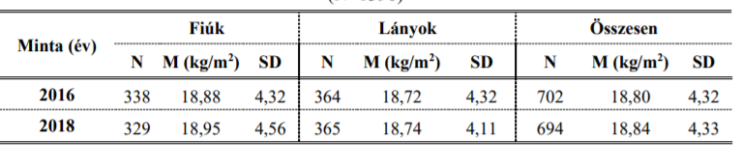 Table 3 -- mean BMI values in the two samples by gender (fiuk=boys, lanyok=girls, osszesen=total)
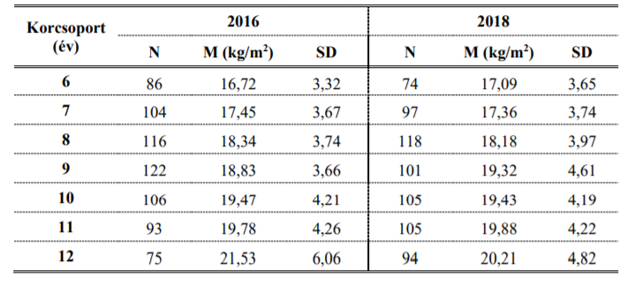
Table 4 -- mean BMI values in the two samples by age groups (korcsoport=age groups)

- Nutritional status

According to comparison of results from the two surveys there is no significant difference between the data obtained from the two surveys, which can be explained by the composition of the population, lack of activity of the parents and economic-social factors. Significant results are seen in girls aged 11-12, but it has no effect on statistical results due to the small sample size. At the same time, results of the knowledge-level survey show significant progress, which clearly suggests that the knowledge provided has been mastered. Results of the project are likely to be statistically valid only later, therefore the sponsor provides resources for an one year maintenance.

Human resources and budget:

The annual budget depends on the size of the community: 55.000-65.000 EUR/year (middle-sized communities with 20.000-40.000 inhabitants)

Budget distribution (estimate):
20% -- salary of the project manager and local coordinator
30% -- fee of the collaborating dietitians, wage costs
30% -- production of informational materials, cost of media support
10% -- measurements (equipments etc.)
10% -- administration and other costs (printing, travel, licences etc.)

Due to the lack of public funding in Hungary, budget of the program is provided by private partners, but governance rules of the project garantee preservation of the public-health objective and prevent possible conflict of interest. Private partners do not intervene the program's content; do not associating the GYERE program with any promotion of a product or brand; only referring to the relationship as part of a corporate social responsibility commitment and partner’s logo is not displayed on any GYERE materials distributed in schools and other local childhood settings.

The GYERE program has one full-time program manager (employed by the HDA) and one part-time local project coordinator (delegated by the municipality, paid by the project). Number of other staff (collaborating dietitians, family health visitors) differs from venue to venue based on the number of beneficiaries.

Communication plan & media results:
The Hungarian Dietetic Association is mobilizing a wide portfolio of communication tools to raise the profile of prevention of childhood obesity as a public health priority via dissemination of program results toward different stakeholders.

Governmental forum:

- Outreach to the Ministry of Human Capacities, State Secretary of Health and Sport, department heads within the Ministry responsible for public health to inform on study results, objectives and details of the intervention
- Continuous communication with the mayor and local government of the project communities

HCP stakeholder outreach:

- publication of study results in scientific papers
- partnerships with relevant national institutions (Semmelweis University, National Institute of Children’s Health) to create a strong professional support to the intervention program and synergies with other health prevention programs
- lectures, symposia on selected key scientific events
- one on one meeting with the WHO local representative
- knowledge sharing with EFAD and ICDA

Media outreach:

- press conference and press releases for the national and local media (at least 3-4 times during a 3 years project period; kick off, study results, outcomes of the educational program)
- story-telling to generate coverage on program
- continuous communication via local media channels of the invervention communities

Digital media:

- digital communication on website and FB page of the Hungarian Dietetic Association
- Fb pages of the local projects to facilitate parents involvement

Media results (two finished GYERE® projects, cumulated):
- Almost 900 Fb post communicated benefits of active-healthy lifestyle.
- More than 450 parents-teachers meeting was held to inform families about progress of the program.
- PR campaign resulted 344 clippings, reaching out to almost 29 mio people, AVE: 160.000+ EUR (earned media)

Objective of the Hungarian Dietetic Association is to get the GYERE® Children's Health Program to as many communities as possible, so that it can achieve its goal effectively at national level.

ANNEX 1 – visuals

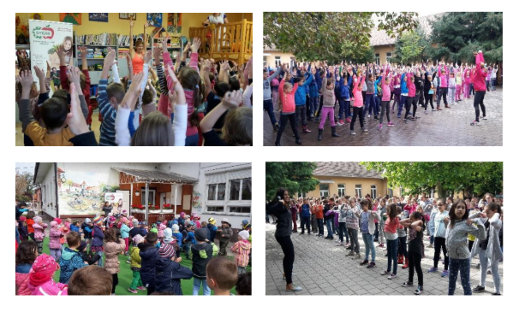
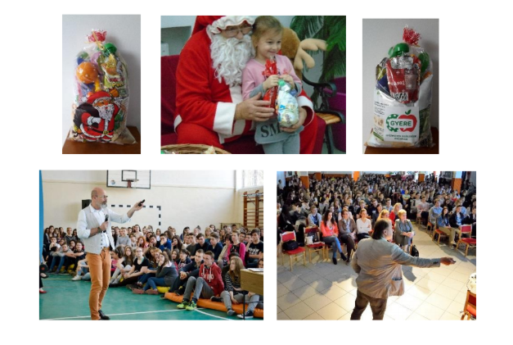
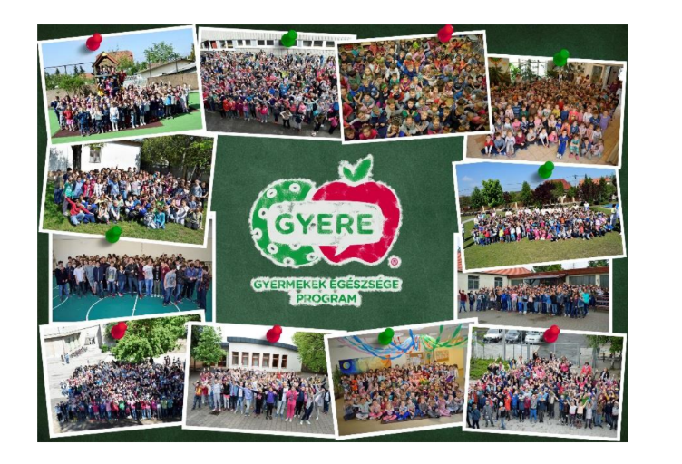
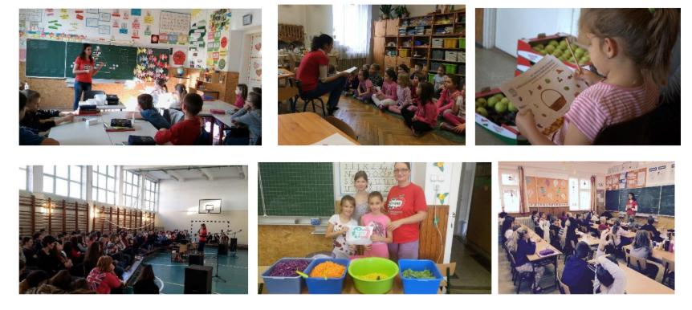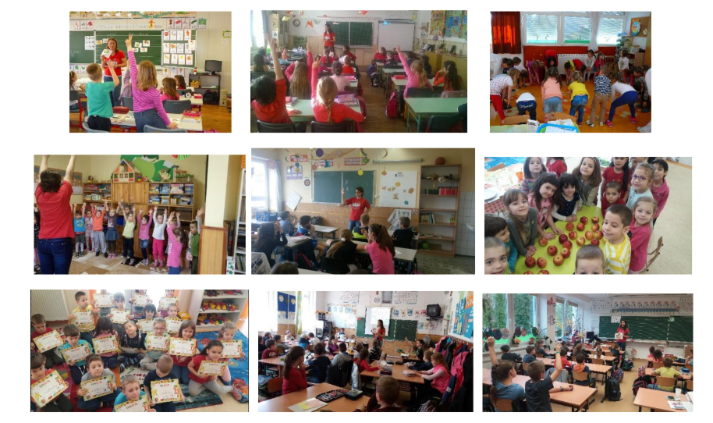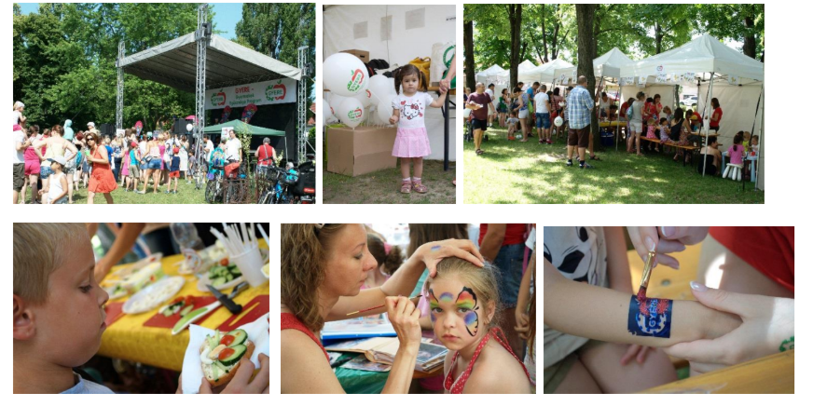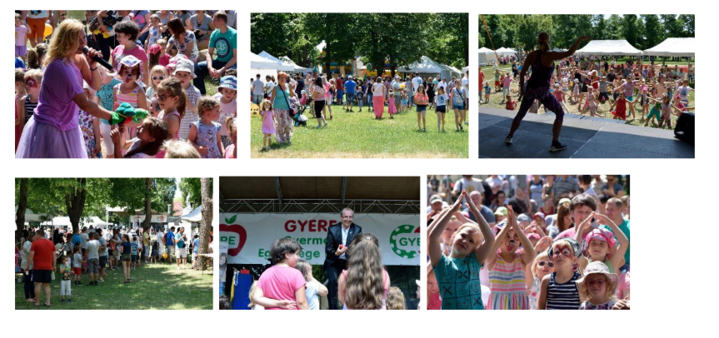

WHO – Ending Childhood Obesity, 2016.
OTAP2014 – National Survey on Nutritional Status and Nutrient Intake in Hungary
OECD Obesity Update 2017.
Borys JM et al. (2012): EPODE approach for childhood obesity prevention: methods, progress and international development. Obes Rev. 2012 Apr; 13(4): 299–315.

